Steps to use the “Get Location” application

1. After opening the application, it will pop up 3 windows. Do not close them or it will cause error.

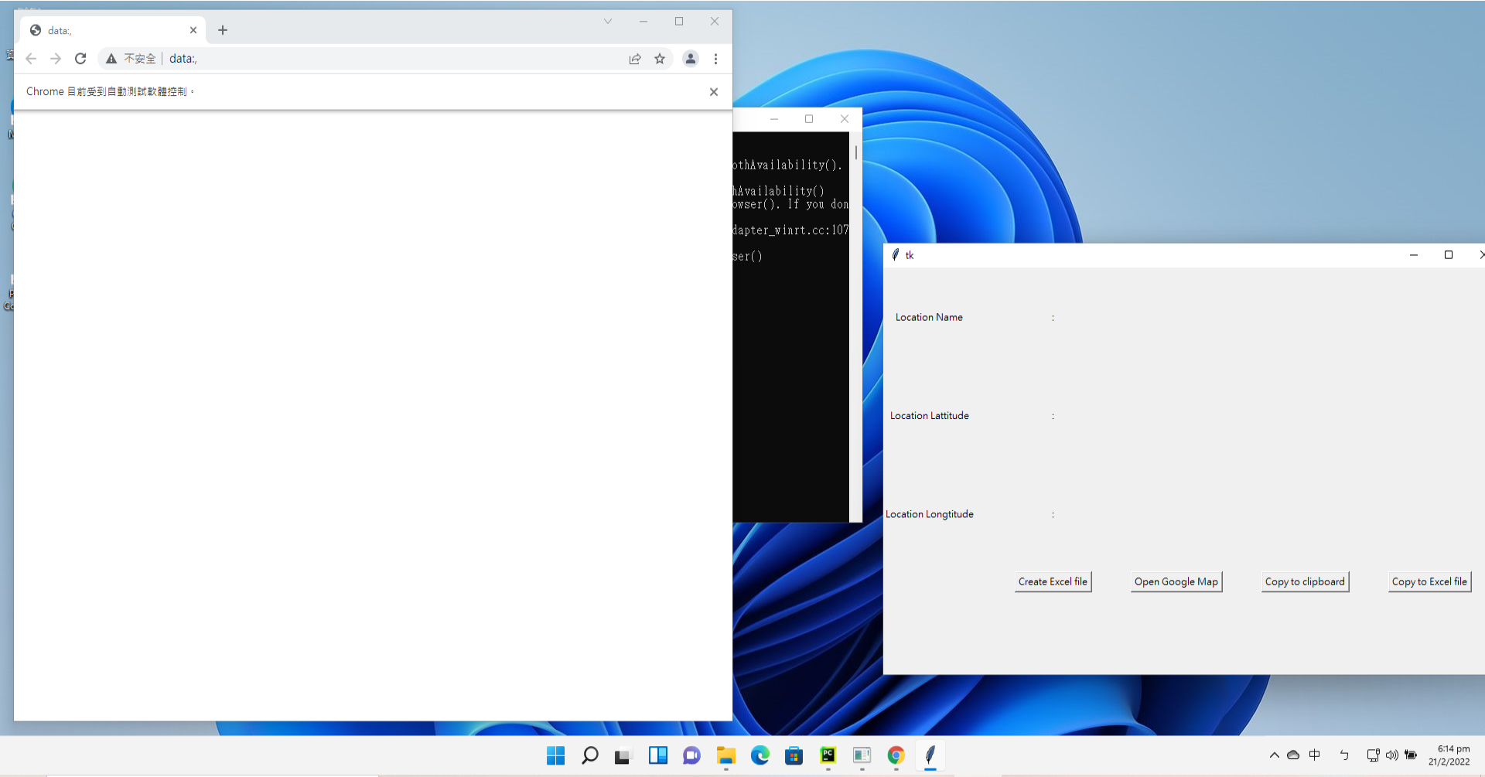

1. Click ”Create Excel File” button and it will create a file “coordinate.xlsx” automatically under the same directory as the application.

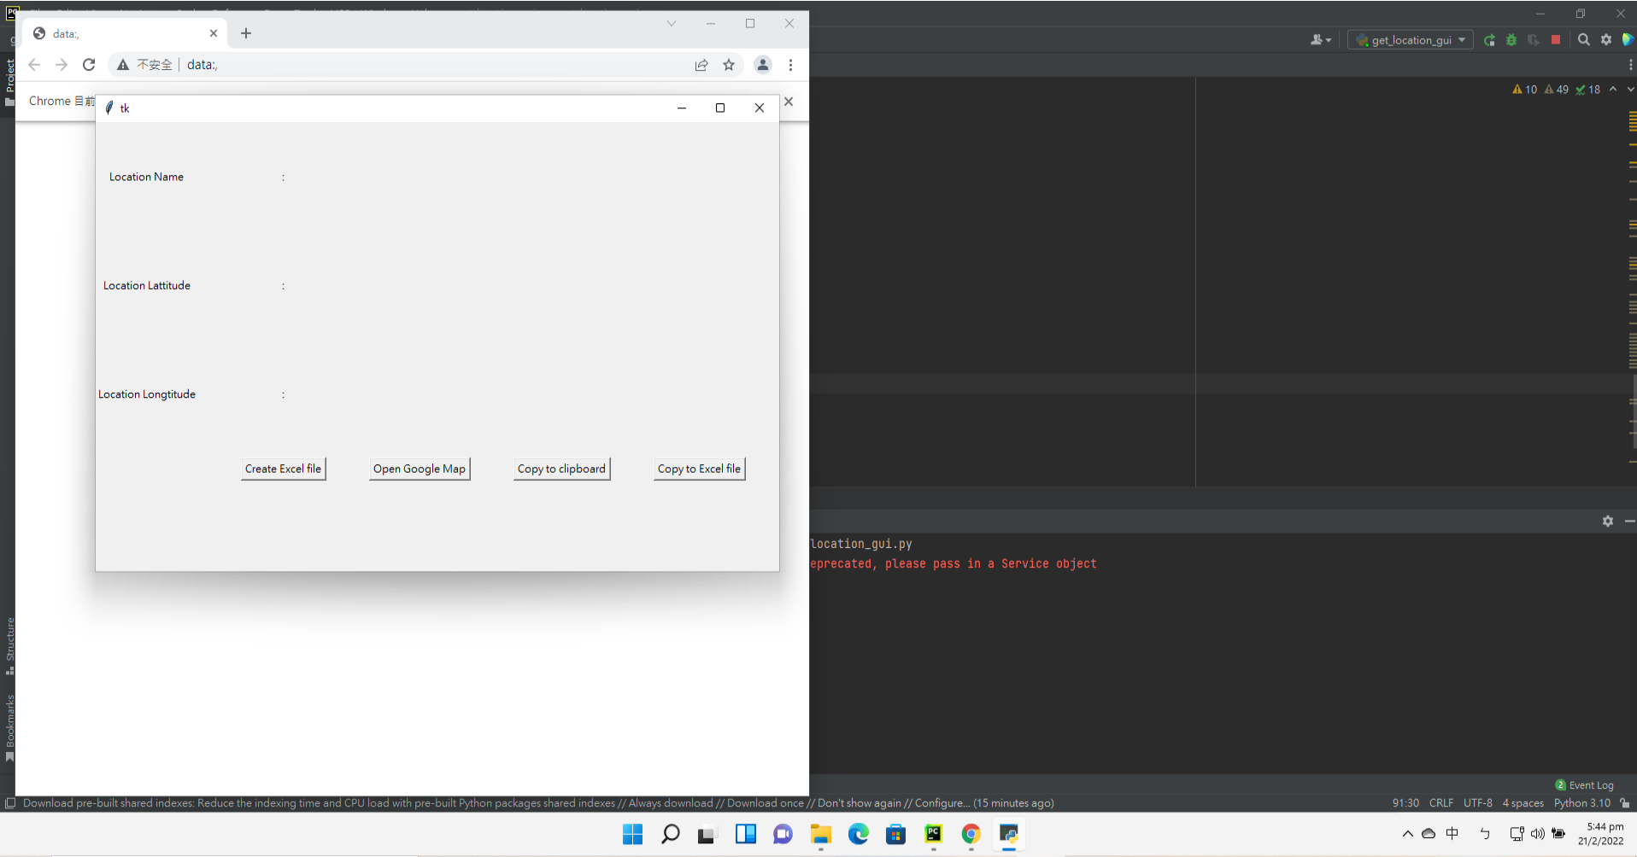

This is the excel file created automatically. **If the file already exist, do not click the button again or else it will overwrite all content in the file.**

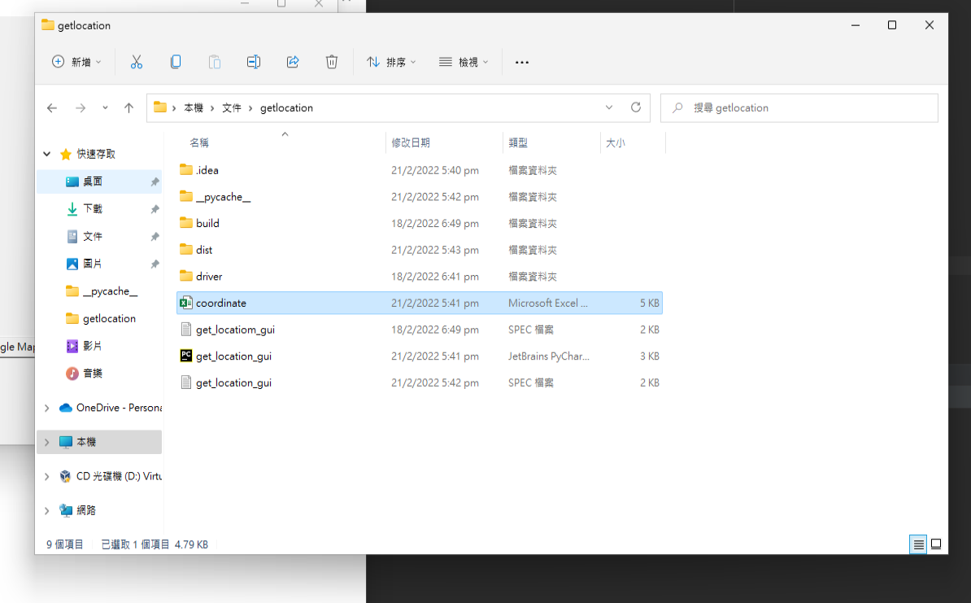

1. Click “Open Google Map” button and Google map will show up like this.

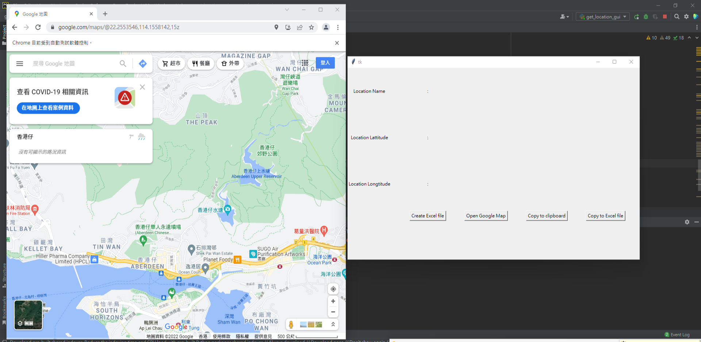

1. After the map is opened, choose the location you want and click” copy to clipboard” or” copy to excel”

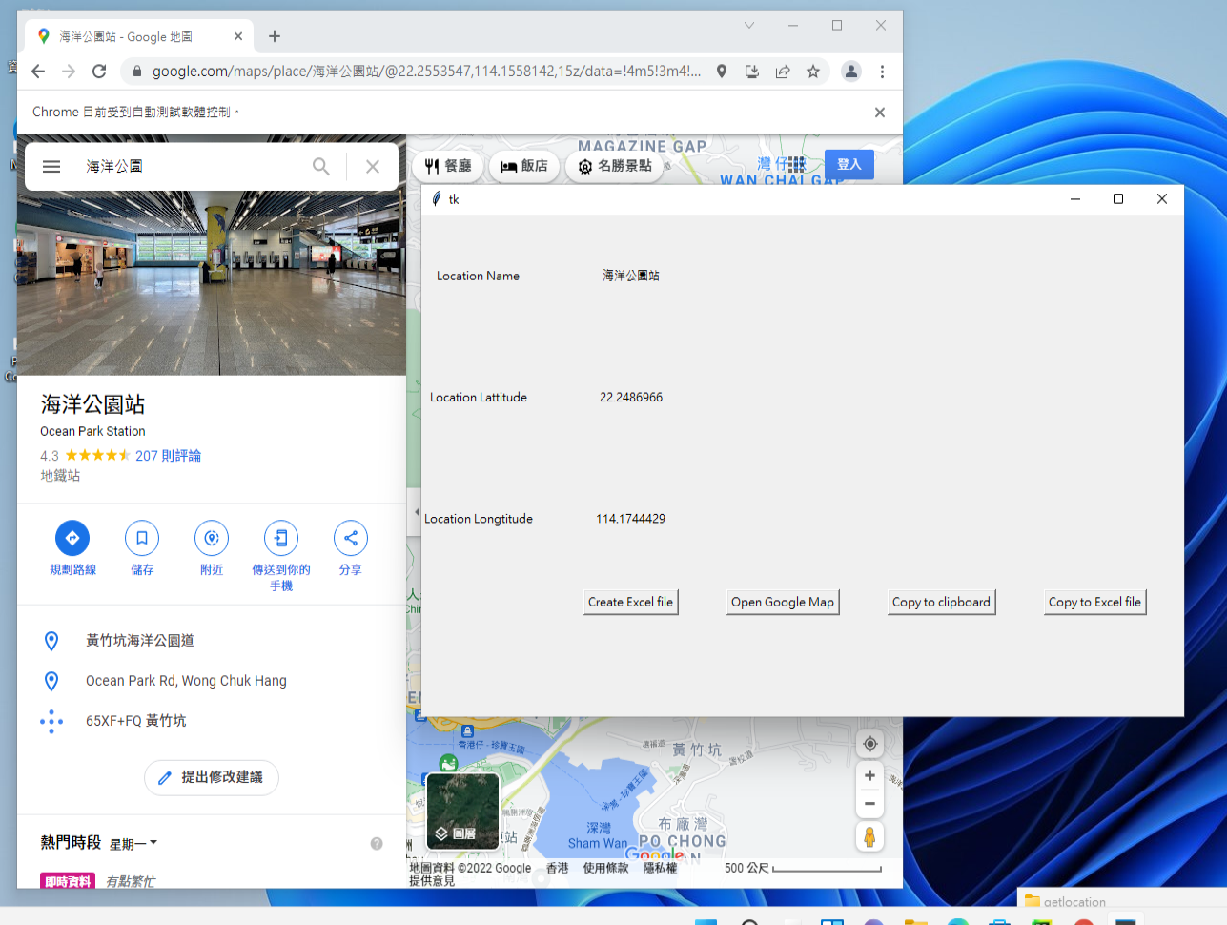

You will be able to see that the application is showing the same location details as the map after you click ” copy to clipboard”

Open the excel file after clicking” copy to excel”, and you should be able to see the location is successfully copied to excel like this

